## **CHAPTER 1**

## **INTRODUCTION**

## **1.1 Overview**

In computing, a web application or a web app is a client-server computing program in which the client (including the user interface and client-side logic) runs in a web browser. The common web application includes Webmail online retail sales and online feedback.

Through Java JavaScript HTML PHP and other technology, application-specific methods such as drawing on a screen playing audio, and accessing the keyboard and the mouse all are all possible.

Web developers often use client-side scripting and add functionality especially to create an interactive experience that does not require your page reloading.

## **1.2 Problem Statement**

The exponential rise in digitalization has made online exams a key aspect, which can be very susceptible to impersonation and cheating. The ability to efficiently proctor remote online examinations is an important limiting factor to the scalability of this next stage in education.  
In the absence of a physical supervisor, students can resort to unfair means. With proper proctoring policies in place, online exams can be made cheat-proof and impersonation can be greatly reduced.  
We aim to develop a web application that performs automatic online exam proctoring.

## **1.3 Motivation**

The online examination system is used by educational institutions to improve the quality of instruction by having a supervised measure of outcomes for self-paced learning environments of their students. The reason E-learning became so popular is because of its fast feedback in assessing the examiners or candidates.

During this pandemic situation as every college was forced to conduct online exams which were leading to students being able to easily use different ways to copy in the exams as there would be no proctoring. An online examination system that has the ability to address academic malpractice should be the main concern to be able to trim down those acts to some degree.

## **1.4 Web Technology**

* Web programming refers to the writing, markup, and coding involved in Web development, which includes Web content, Web client and server scripting, and network security.
* Web programming can be briefly categorized into client and server coding. The client-side needs programming related to accessing data from users and providing information. It also needs to ensure there are enough plugins to enrich the user experience in a graphic user interface, including security measures.
* To improve user experience and related functionalities on the client-side, JavaScript is usually used. It is an excellent client-side platform for designing and implementing Web applications.
* HTML5 and CSS3 support most of the client-side functionality provided by other application frameworks.

## **1.5 Web Applications**

* In computing, a web application or a web app is a client-server program that the client (including the user interface and the client-side logic) runs in a web server.
* Common web applications include Webmail online rental sale and online auction.
* Web applications use a combination of server-side scripts (PHP and asp) to handle the storage and retrieval of information to the client-side script (HTML JavaScript) to present information to users.
* This system allows users to interact with the company using online forms, content management systems, shopping carts, and more. In addition, the application allows the employees to create a document, share information, collaborate on a project, and what can be a common document regardless of a location or device.

## **CHAPTER 2**

## **REQUIREMENT ANALYSIS**

The purpose of this paper is to examine the different methods in gathering requirements.Requirements are one of the most vital pieces to ensure the success of a system or project.To ensure the optimal requirements are received, the methods in which those requirements are obtained are equally important.

## **2.1 Requirement Specification**

### **Online Registration / Enrollment of Students :-**

* Online login.
* Online Schedule.
* Online Examination.
* Online Result declaration.

**Functional Requirements:-**

* Managing question banks of various subjects.
* Deploying the test in full screen mode.
* Prevention of copy-pasting and disabling users from switching tabs or opening the windows**.**
* The system should handle multiple exams at the same time.
* Managing results of students in different exams.
* Integration of all the records of vacancy.
* Editing, adding, and updating questions in various exams.
* To provide a login interface through which only authorized users can pass by.
* Evaluation of answers after the examination.
* To functionally enable Exam Dept Admin to manage Question Bank
* To functionally enable Exam Dept Admin to declare schedule and Results.

### **Non-Functional Requirements:-**

* The system should be reliable and robust.
* The system should be User Friendly.
* The system should be completely consistent and secure.

### **Interface Requirements:-**

* The Interface should be very easy to follow.
* The Interface should not have hidden buttons.
* The Interface should produce relevant error messages.

## 

## 

## 

## 

## 

## 

## **CHAPTER 3**

## **SYSTEM REQUIREMENT SPECIFICATION**

Requirement analysis is critical for project development. Requirements must be documented, actionable, measurable, testable, and defined to a level of detail sufficient for system design.

Requirements can be architectural, structural, behavioral, functional, and non-functional. A software requirements specification (SRS) is a comprehensive description of the intended purpose and the environment for software under development.

## **3.1 Hardware requirement**

* Minimum of 2GB of main memory.
* Minimum of 3GB of storage.
* Keyboard.
* Mouse.
* Display unit.
* Dual-Core or AMD with a minimum of 1.5 GHz speed.

## **3.2 Software requirement**

* Windows-XP/7/8/10 or macOS Big Sur/macOS.
* vsCode.
* Xampp Control Panel.
* Browser- Chrome,Firefox.

## **CHAPTER 4**

## **ANALYSIS AND DESIGN**

The core part of website development and design is not necessarily the coding process. Indeed, such technologies as HTML, CSS, and JavaScript give the web knowledge about its shape and define the way we interact with the information. But what usually stays behind the scenes and, at the same time, remains the crucial part of the website development life cycle are the stages of preliminary information gathering, detailed planning, and post-launch maintenance.

We have followed some of the steps of the Website Development Life Cycle to do our mini-project.

## **4.1 Website development life cycle**

**Step 1.** **Gathering Information:**

The most important task at this point is to get a clear understanding of your future website purposes, the main goals you wish to get, and the target audience you want to attract to your site. Such a website development questionnaire helps to develop the best strategy for further project management.

**Step 2.** **Planning:**

At this stage of the website development cycle, the developer creates the data that can give to a customer an opportunity to judge how the entire site will look like.

On the basis of the information that was gathered together in the previous phase, the sitemap is created.

**Step 3.** **Design:**

The website layout is the result of the designer’s work. It can be a graphic sketch or an actual graphic design. The primary function of the layout is to represent the information structure, visualize the content, and demonstrate the basic function. Layouts contain colours, logos, images and can give a general understanding of the future product.

**Step 4. Content Writing and Assembly:**

Content writing and compiling usually overlaps with other stages of website creation and its role cant be underestimated. At this step, it is necessary to put in writing the very essence you would like to communicate to the audience of your website and add calls to action. Content writing involves also the creation of catching headlines, text editing, writing new text, compiling the existing text, etc,. Who takes time and effort. As a rule, the client undertakes to provide website content ready to migrate to the site. It is better when all website content is provided before or during website coding.

**Step 5.Coding:**

At this step, you can finally start creating the website itself. Graphic elements that have been designed during the previous stages should be used to create an actual website. Usually, the homepage is created first, and then all sub-pages are added, according to the website hierarchy.

**Step 6. Testing:**

Testing is probably the most routine and important part of a process. Every single link should be tested to make sure that there are no broken forms and scripts that are used must be tested before deploying the project, validation of user input must be done.

## **4.2 DOM(Document Object Model)**

The DOM is a cross platform and language-independent application programming interface (API) that treats HTML,XHTML and XML documents as a tree structure where in each node is an object representing a part of the document. The DOM model represents a document with a logical tree. Each branch of the tree ends in a node, and each node contains objects.DOM method allows programming access to the tree;l with them you can change the document's structure, style or content. Nodes can have event handlers attached to them. Once an event is triggered, the event handlers get executed.

## **4.3 Data Flow**

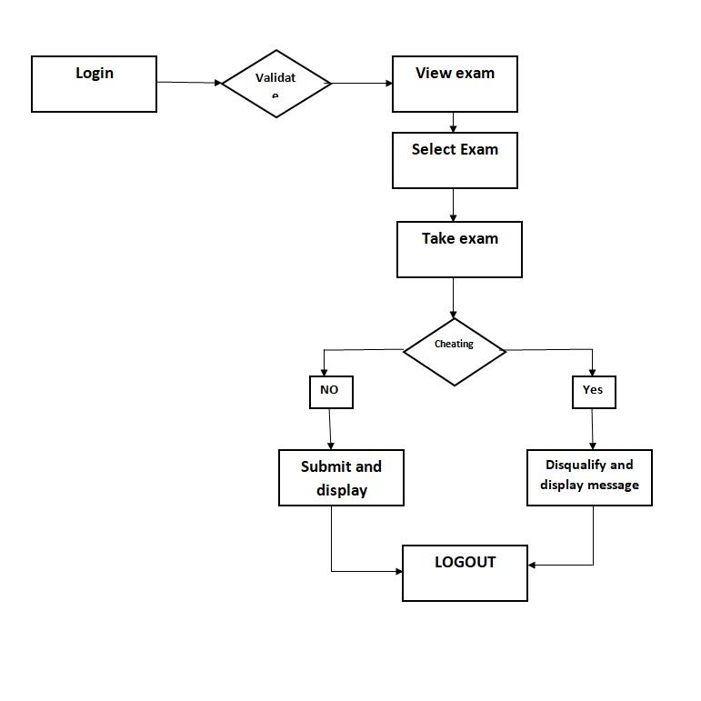

## **CHAPTER 5**

## **IMPLEMENTATION**

## **5.1 File Structure**

The below figure depicts the file structure of the project that has been implemented.

## **5.2 Technology Used**

**5.2.1 HTML (HyperText Markup Language)**

Hypertext Markup Language (HTML) is the standard [markup language](https://en.wikipedia.org/wiki/Markup_language) for documents designed to be displayed in a [web browser](https://en.wikipedia.org/wiki/Web_browser).HTML describes the structure of a [web page](https://en.wikipedia.org/wiki/Web_page) [semantically](https://en.wikipedia.org/wiki/Semantic_Web) and originally included cues for the appearance of the document.[HTML elements](https://en.wikipedia.org/wiki/HTML_element) are the building blocks of HTML pages. With HTML constructs, [images](https://en.wikipedia.org/wiki/HTML_element#Images_and_objects) and other objects such as [interactive forms](https://en.wikipedia.org/wiki/Fieldset) may be embedded into the rendered page. HTML provides a means to create [structured documents](https://en.wikipedia.org/wiki/Structured_document) by denoting structural [semantics](https://en.wikipedia.org/wiki/Semantics) for text such as headings, paragraphs, lists, [links](https://en.wikipedia.org/wiki/Hyperlink), quotes, and other items. HTML elements are delineated by tags, written using [angle brackets](https://en.wikipedia.org/wiki/Bracket#Angle_brackets).

**5.2.2 CSS (Cascading Style Sheets)**

Cascading Style Sheets (CSS) is a [style sheet language](https://en.wikipedia.org/wiki/Style_sheet_language) used for describing the [presentation](https://en.wikipedia.org/wiki/Presentation_semantics) of a document written in a [markup language](https://en.wikipedia.org/wiki/Markup_language) such as [HTML](https://en.wikipedia.org/wiki/HTML).CSS is designed to enable the separation of presentation and content, including [layout](https://en.wikipedia.org/wiki/Page_layout), [colors](https://en.wikipedia.org/wiki/Color), and [fonts](https://en.wikipedia.org/wiki/Typeface). This separation can improve content [accessibility](https://en.wikipedia.org/wiki/Accessibility), provide more flexibility and control in the specification of presentation characteristics.

**5.2.3 JS (JavaScript)**

JavaScript is a [programming language](https://en.wikipedia.org/wiki/Programming_language) that conforms to the [ECMAScript](https://en.wikipedia.org/wiki/ECMAScript) specification.[[7]](https://en.wikipedia.org/wiki/JavaScript#cite_note-tc39-7) JavaScript is [high-level](https://en.wikipedia.org/wiki/High-level_programming_language), often [just-in-time compiled](https://en.wikipedia.org/wiki/Just-in-time_compilation), and [multi-paradigm](https://en.wikipedia.org/wiki/Programming_paradigm). It has [curly-bracket syntax](https://en.wikipedia.org/wiki/List_of_programming_languages_by_type#Curly-bracket_languages), [dynamic typing](https://en.wikipedia.org/wiki/Dynamic_typing), [prototype-based](https://en.wikipedia.org/wiki/Prototype-based_programming) [object-orientation](https://en.wikipedia.org/wiki/Object-oriented_programming), and [first-class functions](https://en.wikipedia.org/wiki/First-class_function). As a multi-paradigm language, JavaScript supports [event-driven](https://en.wikipedia.org/wiki/Event-driven_programming), [functional](https://en.wikipedia.org/wiki/Functional_programming), and [imperative](https://en.wikipedia.org/wiki/Imperative_programming) [programming styles](https://en.wikipedia.org/wiki/Programming_paradigm). It has [application programming interfaces](https://en.wikipedia.org/wiki/Application_programming_interface) (APIs) for working with text, dates, [regular expressions](https://en.wikipedia.org/wiki/Regular_expression), standard [data structures](https://en.wikipedia.org/wiki/Data_structure), and the [Document Object Model](https://en.wikipedia.org/wiki/Document_Object_Model) (DOM).

**5.2.4 PHP**

PHP is a [general-purpose](https://en.wikipedia.org/wiki/General-purpose_programming_language) [scripting language](https://en.wikipedia.org/wiki/Scripting_language) especially suited to [web development](https://en.wikipedia.org/wiki/Web_development).PHP code is usually processed on a [web server](https://en.wikipedia.org/wiki/Web_server) by a PHP [interpreter](https://en.wikipedia.org/wiki/Interpreter_(computing)) implemented as a [module](https://en.wikipedia.org/wiki/Plugin_(computing)), a [daemon](https://en.wikipedia.org/wiki/Daemon_(computing)), or as a [Common Gateway Interface](https://en.wikipedia.org/wiki/Common_Gateway_Interface) (CGI) executable. On a web server, the result of the interpreted and executed PHP code – which may be any type of data, such as generated [HTML](https://en.wikipedia.org/wiki/HTML) or binary image data – would form the whole or part of an [HTTP](https://en.wikipedia.org/wiki/Hypertext_Transfer_Protocol) response. Various [web template systems](https://en.wikipedia.org/wiki/Web_template_system), web [content management systems](https://en.wikipedia.org/wiki/Content_management_system), and [web frameworks](https://en.wikipedia.org/wiki/Web_framework) exist which can be employed to orchestrate or facilitate the generation of that response.

**5.2.5 BOOTSTRAP**

Bootstrap is a [free and open-source](https://en.wikipedia.org/wiki/Free_and_open-source) [CSS framework](https://en.wikipedia.org/wiki/CSS_framework) directed at responsive, [mobile-first](https://en.wikipedia.org/wiki/Responsive_web_design#Mobile_first,_unobtrusive_JavaScript,_and_progressive_enhancement) [front-end web development](https://en.wikipedia.org/wiki/Front-end_web_development). It contains [CSS](https://en.wikipedia.org/wiki/CSS)- and (optionally) [JavaScript](https://en.wikipedia.org/wiki/JavaScript)-based design templates for [typography](https://en.wikipedia.org/wiki/Web_design#Typography), [forms](https://en.wikipedia.org/wiki/Form_(HTML)), [buttons](https://en.wikipedia.org/wiki/Button_(computing)#HTML), [navigation](https://en.wikipedia.org/wiki/Web_navigation#Local_website_navigation), and other interface components. Once added to a project, Bootstrap provides basic style definitions for all [HTML elements](https://en.wikipedia.org/wiki/HTML_element). The result is a uniform appearance for prose, tables, and form elements across [web browsers](https://en.wikipedia.org/wiki/Web_browser).

## **5.3 Server Side Main Functions**

There are 6 tables in the database.

* **admin**:-   
  Stores the details about the admin ie name, email and password.
* **student**:-   
  stores the details about the student i.e name, email and password.
* **exam_name**:-  
   Contains the details of the exam name and the exam_id.
* **questions**:-   
  Contains question, question number and exam_id.
* **Choices**:-  
   Contains choice_id, question_number, option and correct_answer
* **Marks**:-  
   Contains the scores of the student of a particular exam

**To establish the connection with database**

$db_host = 'localhost';

$db_name = 'quizzer';

$db_user = 'root';

$db_pass = '';

$mysqli = new mysqli($db_host,$db_user,$db_pass,$db_name);

**To execute query and get the boolean value in return**

$query = $mysqli->query("select * from exam");

**To get the count of the rows**

$num = $query->num_rows

**To get one row after other and free the connections**

$row = $query->fetch_assoc()

## **CHAPTER 6**

## **TESTING**

## **6.1 Testing Techniques**

Software testing techniques help you design better cases. Since exhaustive testing is not possible, testing techniques help reduce the number of test cases to be executed while increasing test coverage. They help identify test conditions that are otherwise difficult to recognize.

## **6.2 Software Testing Fundamentals**

During earlier definition and development of software quality assurance and represents the ultimate review of specification,, design and coding. The increasing visibility of software as a system element and attendant “costs” associated with a software failure is a motivating force for well planned, through testing.

## **6.3 Testing Objective**

A number of rules that can serve well as testing objectives:

* Testing is a process of executing a program with the intent of finding an error.
* A good test case is one that has high probabilities of finding an undiscovered error. A successful test is one that uncovers as undiscovered error.
* The objective is to design test systematically to uncover different classes of errors and do so with minimum amount of time and effort.

Testing cannot show the absence of defects. It can only show the software defects that are present.

## **6.4 Test Cases**

|  |  |  |  |  |
| --- | --- | --- | --- | --- |
| Case id | **Description** | Expected output | Actual Output | Status |
| 1. | Test whether user login works properly | Should log in for valid users | Login was successful | PASS |
| 2. | Testing whether admin login works properly | Should log in for valid admin | Login was successful | PASS |
| 3. | Testing whether the score is calculated | Should validate the question and option | Correct Score was displayed | PASS |
| 4. | Issuing the certificate if the cutoff criteria are met | Should validate the cutoff criteria | The certificate was displayed when criteria were met | PASS |
| 5. | Disqualifying the user if malpractice identified | Should check for tab switching, copy-pasting, opening a new browser, opening the test in new tab | Disqualifying the user if malpractice found | PASS |

## **CHAPTER 7**

## **SNAPSHOTS**

Fig 7.1 HomePage

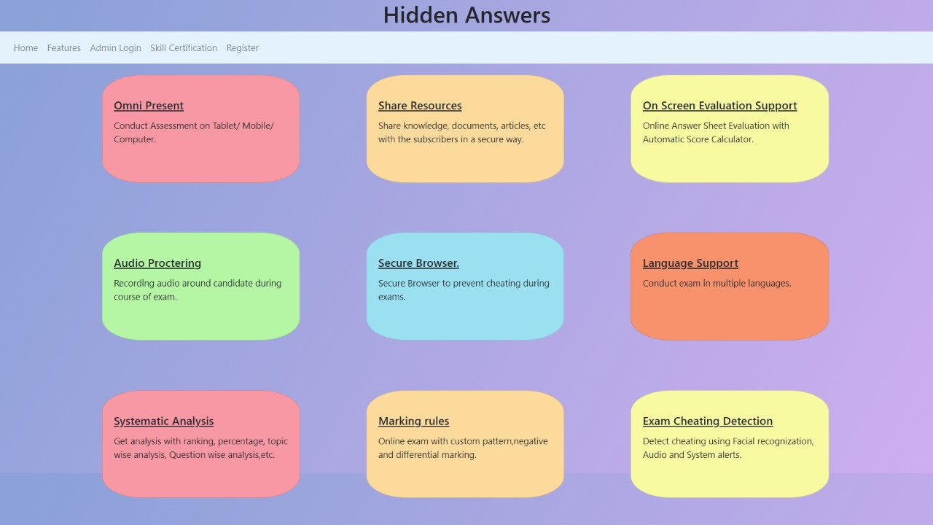

Fig 7.2 Features

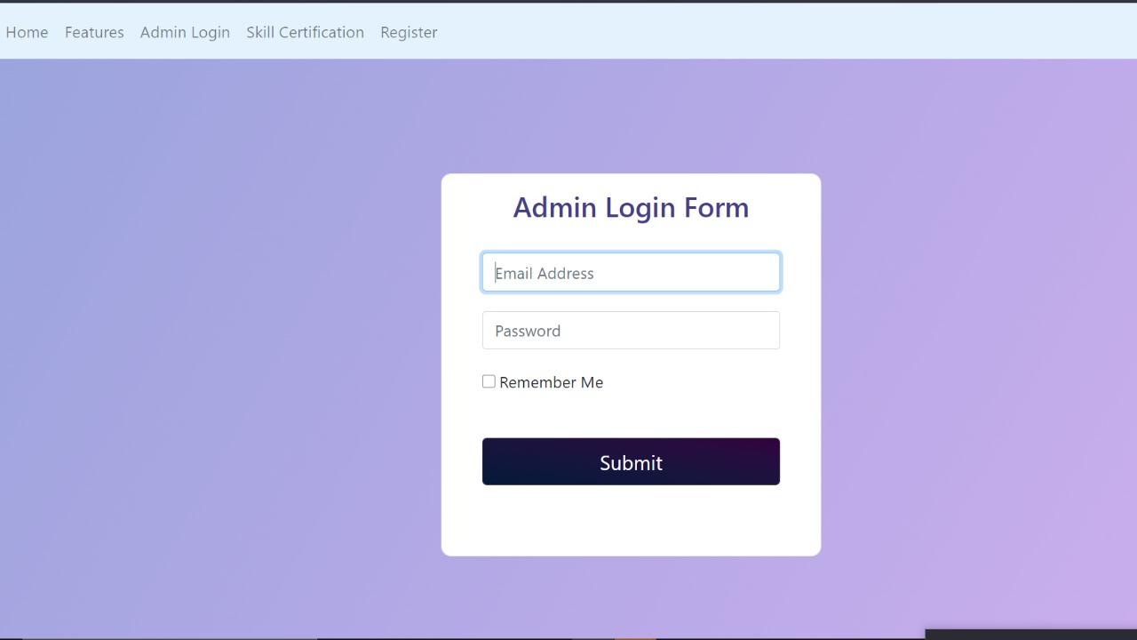Fig 7.3 Admin Login Form

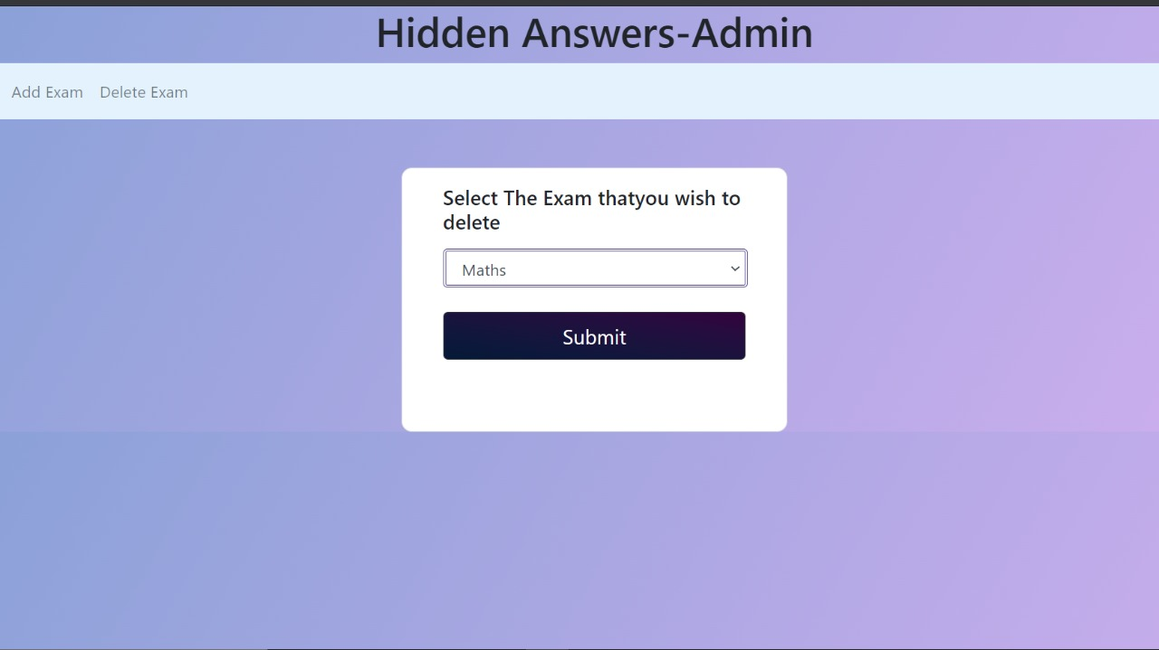

Fig 7.4 Admin- Delete Exam  
Here admin can delete exams

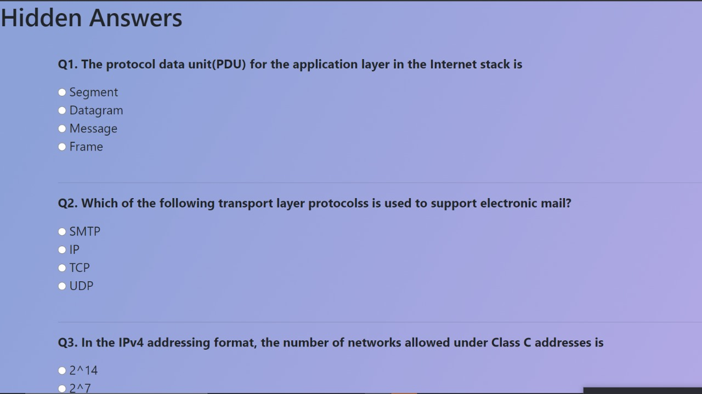

Fig 7.6 Student exams  
Exam questions for student

## 

Fig 7.7 Student Warnings  
Warnings to be shown to student when tries to copy

## 

Fig 7.5 Admin- Add Questions for Exam

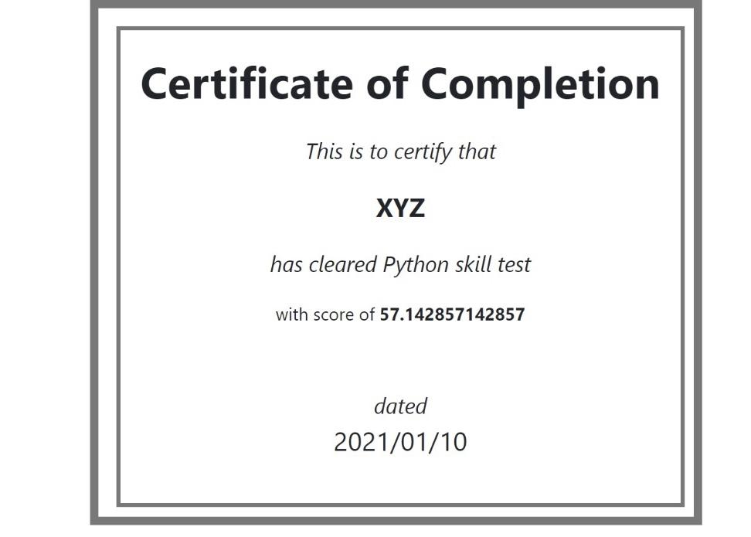

Fig 7.8 Certificate of completion when student finishes exam

## **CONCLUSION**

In an ever-evolving education scenario, online exams and e-assessments are at the center of it all,with the aid of this software we can ensure transparency and bias-free results to the students.

The Online Examination System with Cheating Prevention by Disabling Copy Pasting, question randomization and Tab Locking aims to maintain academic integrity in e-learning.Excellent in terms of efficiency, the system works and gives immediate feedback in assessing the examiners.

For this reason, the system can be used to be deployed on educational institutions that want to have an online examination system that has the ability to address academic malpractice.

## **FUTURE ENHANCEMENT**

* Online Payment for paid examinations.
* A module from where entities can communicate.
* Faster process for Subjective paper Evaluation.

## **REFERENCES**

1. [www.google.com](http://www.google.com)
2. <https://en.wikipedia.org/wiki/Main_Page>
3. <https://www.w3schools.com/>
4. <https://stackoverflow.com/>
5. https://getbootstrap.com/